Practical 10

**Implement Node js program to read data from file "input.txt" and write these data to "output.txt" using concept of streams.**

Node Js Code :-

|  |
| --- |
| const fs = require('fs'); const readStream = fs.createReadStream('input.txt', { encoding:  'utf8' }); const writeStream = fs.createWriteStream('output.txt', { encoding:  'utf8' });  readStream.on('data', (chunk) => { writeStream.write(chunk);  });  readStream.on('end', () => { writeStream.end();  });  writeStream.on('finish', () => {  console.log('Data has been written to output.txt'); }); |

Input.txt File:

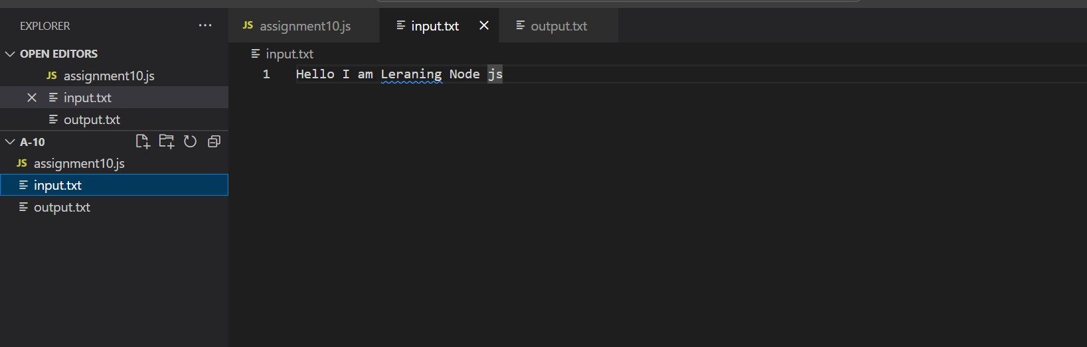

Output of Code :-

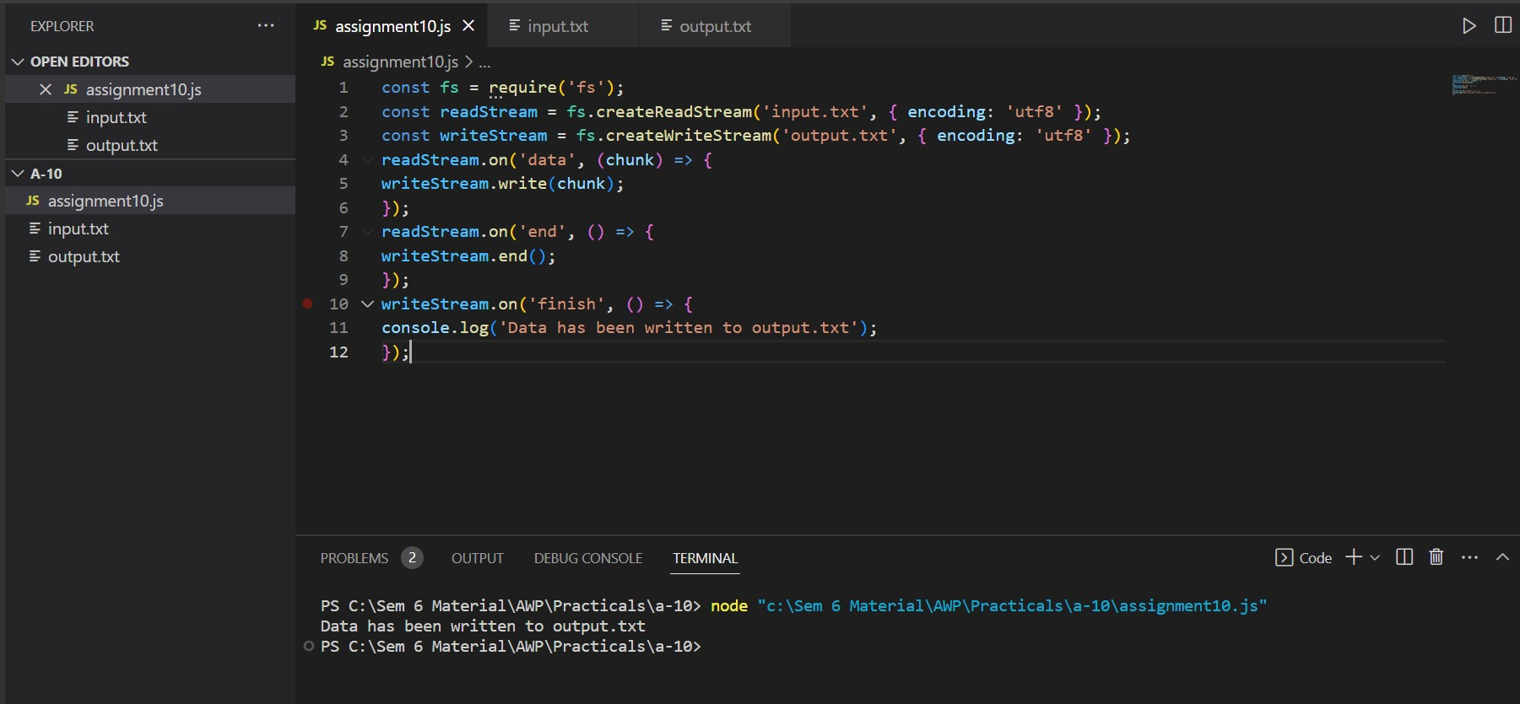

Output.txt File:

